

2600 Series Installation and Troubleshooting Instructions

Revised 01/11/17

Contents

Hardware List 3

Wiring 4

Wired Device Installation Guide 5

Troubleshooting 8

Installing Mercury Switch 10

Installing Seat Switch 11

INSTALLATION MANUAL FOR EAGLE EYE HARDWARE

# Hardware List

Item Name Quantity

|  |  |
| --- | --- |
| GPS Device | 1 Per Truck |
| Wiring Harness | 1 Per Truck |
| Mercury Switches | 2 Per Truck (On Vehicles Requiring) |
| Seat Switch | 1 Per Truck (Optional) |

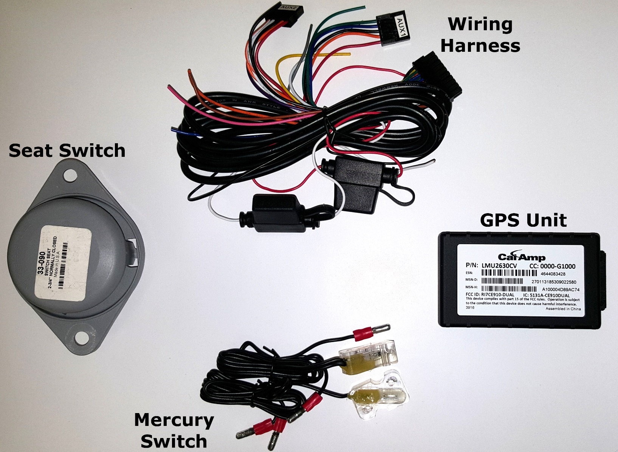

# Wiring

**Data Collector Inputs:**

|  |  |  |  |  |
| --- | --- | --- | --- | --- |
|  | **Small Vacuums** | **Large Vacuums** | **Whirlwinds** | **Brooms** |
| **Wire Color** |
| White (INPUT 0 PIN 8) | Front Engine Ignition | Front Engine Ignition | Front Engine Ignition | Front Engine Ignition |
| Blue (INPUT 1 PIN 3) | Seat Switch | Right Gutter Broom Down | Right Nozzle Down | Right Gutter Broom Down |
| Orange (INPUT 2 PIN 12) | Head Down | Head Down | Center Broom Down | Rear Broom Down |
| Violet (INPUT 3 PIN 6) | Left Gutter Broom Down | Left Gutter Broom Down | Left Nozzle Down | Left Gutter Broom Down |
| Grey Wire (INPUT 4 PIN 7) | Hr Meter | Hr Meter | Hr Meter | Hr Meter |
| None Assigned |  | Job Start/Stop | Job Start/Stop | Job Start/Stop |
|  |  |  |  |  |
| Black Wire | 12 Volt Negative | | | |
| Red Wire | 12 Volt Positive With 5 Amp Inline Fuse | | | |

**INPUT POWER MUST COME DIRECTLY FROM THE BATTERY ONLY**

# Wired Device Installation Guide

LMUs with internal antennas should be placed to maximize their GPS performance with the white label facing the sky. A typical location is under the dash close to the front wind-shield. Attach the LMU to the solid body of the vehicle, not to plastic panels. The LMU can be placed out of sight by removing interior trim and molding to expose available space, then replacing the trim once the LMU is in place.





Connect power, ignition, and ground

1. The power input (red wire) must be connected to a constant (un-switched) +12 VDC or+24 VDC supply; preferably, connected directly to the vehicle battery terminal or as close to it as possible. This connection point should be fuse protected to not more than 5 Amps.
2. The ground line (black wire) must be connected to chassis ground. Failure to connect these lines in the manner described may result in discharge of the vehicle battery.
3. The ignition input (white wire input 0 PIN 8) must be connected to the vehicle ignition or another appropriate key operated line, such as ACCESSORY, ensuring that power to the ignition wire is available only when the vehicle ignition is on.
4. Connect the hour meter (grey wire Input 4 PIN 7).
5. Connect the seat switch and mercury switches. See additional instructions on pages 10 & 11.





# Troubleshooting



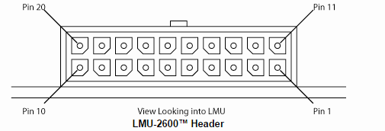

CalAmp 2600 Light sequences:



# Installing Mercury Switch

1. Mount securely to operation; head, gutter broom, nozzle.
2. Run power and input from switch to wiring harness.
3. Connect to either the Orange (input 2 Pin 12), Violet (input 3 Pin 6), or Blue (Input 1 Pin 3)
   1. Please reference the data collector inputs on page 4.
   2. This will describe the correct operation and input based on the vehicle type.
4. Ensure you connect to the wiring harness prior to connecting the power.

# Installing Seat Switch

1. Make template
2. Dimensions of the steel template are 6” x 5” x ¼”
3. Find dead center both vertically and horizontally
4. Mark a 3” circle in the very center of the plate and drill using a 3” hole saw
5. With the 5” side of the plate running vertical and the 6” side running horizontal find dead center and measure 1 13/16” left and right of dead center. Mark these two spots and drill with ¼” drill bit.
6. Remove seat from truck
7. Install template on bottom of seat. Line up template with bend in front edge of seat
8. Screw down template using two ¼” self-tapping screws
9. Cut center hole using a 3” hole saw
10. Remove template
11. Grind down padding so as not to contact switch after it is installed
12. Install switch with the wire’s* facing front of seat. Remove tab on top of switch with grinder
13. Install two ¼” spacer washers on studs in floor
14. Install seat

*Blue Wire (Input 1 Pin 3) on harness to one prong of seat switch and 12 Volt Positive to the other



